President’s Office
REGIONAL ADMINISTRATION AND LOCAL GOVERNMENT
ARUSHA DISTRICT COUNCIL
FORM FOUR PRE-MOCK EXAMINATION – MARCH 2020
033 BIOLOGY

Time:3Hours Tuesday,31st March 2020 a.m
INSTRUCTIONS:
- This paper consists of Sections A, B and C with a total of fifteen (15) questions.
- Answer all questions from section A and B and ONLY TWO question from section C of which question 13 is compulsory.
- Write your examination number at the top right hand corner of every page.
- All writing must be in blue or black ink. Diagrams must be drawn in pencil and labeled in ink.
- Cellphones and any unauthorized materials are not allowed in the examination room.

SECTION A(15 Marks)
Answer all questions in this Section

1. For each of the items (i) – (x) choose the correct answer from among the
given alternatives and write its letter beside the item number.

- Fertilization of human eggs most often takes
place in the:
A. Ovary B. Vagina
C. uterus D. Oviduct [ ]
- The main aim of respiration is:
A. To release energy
B. Intake of oxygen
C. Fermentation of Glucose
D. Release of carbondioxide [ ]
- A person stretched out his arm to the left
to cause the motion of the arm, his:
- Biseps contracted white triceps relaxed
- Biseps and triceps both relaxed [ ]
- Triceps contracted while biseps relaxed
- Biseps and triceps did not contract or relax
- Among the following, which of the organism
is a protist?
A. Earth warm B. Euglena
C. Tsetse fly D. Lice [ ]
- A colour blind woman marries a man with normal vision. What percentage of colour blind and normal children would be expected from such a marriage?
A. 100% colour blind
B. 50% colour blind and 50% normal
C. 25% normal and 75% colour blind
D. 100% normal [ ]
- Which of the following insects show incomplete metamorphasis?
A. Mosquito B. Butterfly
C. Grasshopper D. Moth [ ]

- Which of the following does not show homology?
- Beaks in birds
- Foot structure in birds
- Pentadactyl structures in vertebrate
- Wings in birds and insects [ ]

- During cold weather shivering occurs in a mammalian body in
order to:
A. Generate heat B. Shake off coldness
C. produce sweat D. Relax the muscles [ ]
- Ferns belong to division:
A. Filicinophyta B. Bryophyta [ ]
C. Angiospermophyta D. Coniferophyta

- The name of red pigment with iron found in
the red blood cells is:
A. Myoglobin B. Bile
C. Haemoglobin D. prothrombin [ ]
- Match the responses in LIST B with the word/phrases in LIST A by writing the letter of the correct response beside the item number:
- Coelomate.  - Fasciola  - Eukaryote  - Bacillus  - Pteridophytes | L.Trematoda  M.fern plant  N.body cavity  O.plant  P.Rod-shaped bacteria  Q.Moss Plant  R.Bacteria  S.Body Segmented  T.Cestoda  U.Spherical-Shaped Bacteria

SECTION B(60 Marks)
Answer ALL questions in this section:

3. (a) (i) What is breathing?
(ii) List down four roles of the alveoli

(b) Explain why it is better to breath through your nose than it is to breath
through your mouth.

4. (a) (i) Distinguish between phototropism and geotropism.
(ii) Name the hormone responsible for tropic response in plants.
(b) What are the effects of the following hormones in man?
(i) Insulin
(ii) Antidiuretic Hormane (Vasopressin).

5. (a) Define the following:
(i) Nutrition (ii) Growth
(b) Outline four functions of protein in human body.
(c ) In a practical lesson a candidate has been provided with food sample X
fill the table below:

Test for | Procedures | B observation | Inferences
Starch | (i) …………..  …………….. | Food sample X turned blue black | (ii) ………….  ……………
(iii) …….  ………… | To a food sample X, Potassium hydroxide was added and drops of Copper sulphate solution was added | (iv) …………..  ………………. | Protein was present

6. (a) Differentiate the following terms as used in Genetics (with examples).
(i) Incomplete dominance and codominance
(ii) Sex Linkage and Sex limited

(b) List down two causes of variation among
organisms.

7. (a) Name structures responsible for Gaseous exchange in:
(i) Mammal’s (ii) Young tadpole
(iii) An insect (iv) Tilapia

(b) Name the Plant structure concerned with
Gaseous exchange (with the name of the cell
responsible).

8. Observe the following diagram then answer questions that follows:

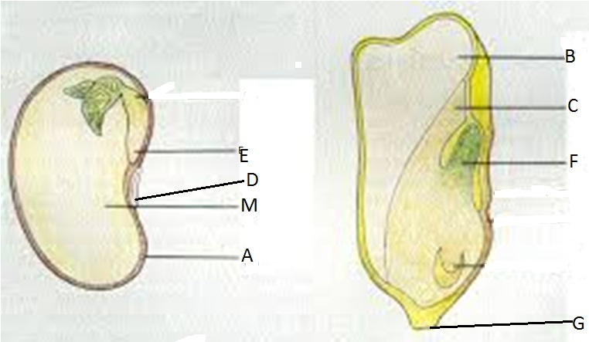
  - Name part A – G
  - After the development of E and F, what new plant parts will be formed?
  - Part B perform the same function with part M.
    - What is M.
    - What is that function it perform?

9. (a) Draw a well labeled diagram of the
Mushroom.
(b) In w hat Kingdom does it (mushroom) belong?
(c ) List down two uses of the organisms in the
kingdom in (b) above.

10. A food chain is given below:
OAK TREE→INSECT LARVAE →INSECTIVOROUS BIRD
- A food chain may be represented in a diagram called a “pyramid of number”
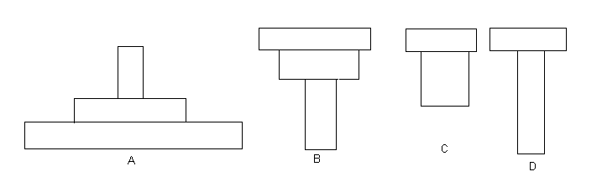

Among the pyramids of number A – D; which
of these will best represent this food chain?
- which is the producer in the food chain?
- Name two main groups of organisms termed to as decomposers.

11. (a) What do you understand by the term 'organic evolution'?
(b) Briefly explain Cosmozoan Theory and Steady-state Theory as explained
in theories of origin of life.

12. Describe the adaptation of mammal living in temperate regions.

SECTION C (25MARKS)
Answer ONLY two (2) questions from this Section: question13 is compulsory.

13. You are a health officer in Meru District which is infected with Malaria.
Educate people on the Malaria by using the following headings in your
discussion:
- Causes of Malaria
- Transmission
- Symptoms
- Effects of Malaria in Man
- Control of the disease

14. Write an essay on the Economic Importance of Insects.

15. Surfaces where useful materials enter the body of an organism are usually
modified to allow maximum surface area for entry of materials.
Giving one example in plants and two examples in Mammals, explain how
an increased surface area may be realized.

